**Exercice php my admin :**

**Exercice 1 :**

SELECT First_Name

From employee

Where First_Name like “b%”

**Exercice 2 :**

SELECT First_Name

From employee

Where First_Name like "%o%"

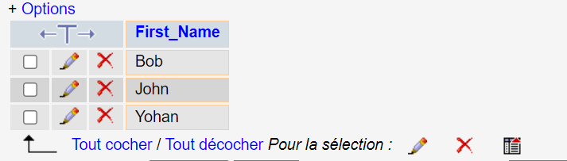

**Exercice 3:**

SELECT First_Name

From employee

Where First_Name like "%n"

**Exercice 4:**

SELECT First_Name

From employee

Where First_Name like "___n"

**Exercice 5:**

SELECT First_Name

From employee

Where First_Name like "j___"

**Exercice 6:**

SELECT First_Name

From employee

Where salary > 300000

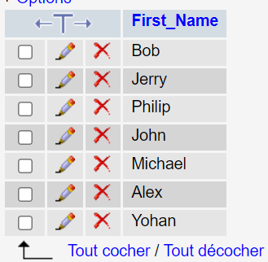

**Exercice 7:**

SELECT First_Name, Departement

From employee

Where Salary > 3000000

**Exercice 8:**

SELECT First_Name

From employee

Where Salary between 2000000 and 5000000

**Exercise 9:**

SELECT First_Name

From employee

Where First_Name="Alex" OR First_Name="Bob"

**Exercice 10:**

SELECT *

From employee

Where year(joining_date)=2019

